If desired, insert golf course logo
Extending environmental efforts with Operation Pollinator
We are excited to announce our involvement with Operation Pollinator, allowing us to establish natural wildflower habitats on our golf course for bumblebees and other pollinating insects. We have a unique opportunity to take advantage of the landscape on our course to preserve and improve pollinator populations, while enhancing the visual appearance of the course.
Why are we involved?
According to research by the Bee Informed Partnership, in 1970, there were approximately four million honey bee colonies in the U.S. In 2012, that number had declined to approximately 2.5 million colonies.¹ Golf course managers around the country are extending their environmental management programs to help pollinators through Operation Pollinator. At (insert golf course name), our area is well-suited to establish natural habitats to help prevent further pollinator decline.
Additionally, we believe Operation Pollinator will:
- Generate pride in our course for (insert specific stakeholders, e.g. members, players, men’s/women’s club teams) and the community.
- Introduce native wildflowers for pollinators, adding beauty to the golf course.
- Attract organizations and players interested in sustainability.
- Create positive publicity for our golf course.
What can you expect?
In the coming months, (insert Operation Pollinator course locations here) will be reserved for Operation Pollinator site(s). (Insert location of site) was chosen because it is an out-of-play area to ensure your game is not interrupted. Our grounds team, led by (insert superintendent’s name and official title), and (insert head pro/club manager name and official title), will properly establish and maintain our Operation Pollinator habitat(s).
In the (insert timing e.g. next few weeks), we will begin removing current vegetation down to bare ground. This will create a terrain for wildflower establishment to thrive without competing with other vegetation. The Operation Pollinator area(s) will then be prepared for planting wildflower seeds custom blended for our course by Applewood Seed Company based on our geography and climate.
Proactive management of habitats have proven to be a success. With modern techniques, we can deliver results more quickly. Initial results will be seen within three to six months after establishment. Within 12 to 18 months, wildflowers and vegetation will be fully established, adding a nectar-rich site for pollinators and beauty for our course.
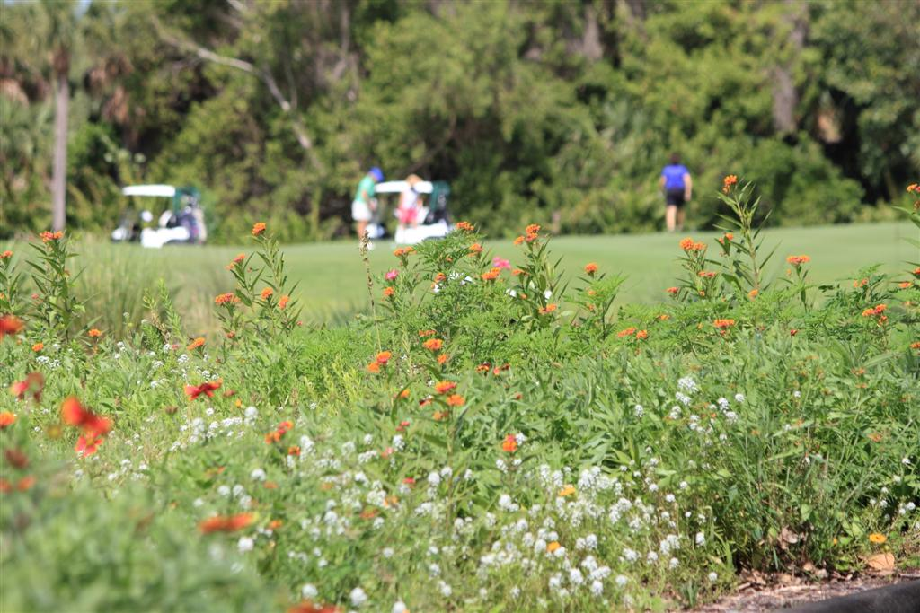
Bee Safety
We understand some people may be concerned with safety risks associated with bee stings. Operation Pollinator sites are designated with signage so you can be aware pollinators are in the area. Foraging bees collect pollen and nectar for their food supply, and will only sting if they are threatened during this process.
We hope you agree Operation Pollinator is a very worthwhile project for us to be involved with and to develop in the future as part of our environmental and ecological management. The grounds team and club management welcome your feedback and comments to add to the value we can deliver with our environmental projects.
For more information about Operation Pollinator, please visit GreenCastOnline.com/OperationPollinator and ApplewoodSeed.com/pollinator.

¹ Spleen, Angela M., Lengerich, Eugene J., Rennich, K., Caron, D., Rose, R., Pettis, Jeff S., Henson, M., Wilkes, James T., Wilson, M., Stitzinger, J., Lee, K., Andree, M., Snyder, R. vanEngelsdorp, D. Journal of Apicultural Research (2013). “A national survey of managed honey bee 2011-2012 winter colony losses in the United States: results from the Bee Informed Partnership.” Web.

©2014 Syngenta.

