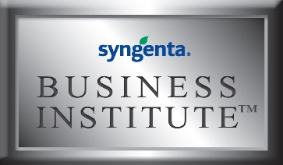
2017 Syngenta Business Institute™ Application
Syngenta Business Institute (SBI) is a unique three-day program for golf course superintendents. SBI provides a business management curriculum that includes financial management, delegation skills, effective communications, negotiation tactics and more.

Completed applications are due by Tuesday, August 15, 2017. Accepted applicants will be notified in October.

*Required

*Application Date:
*Name:
*Golf Course Name:
*Type of course: Please check one.
☐ Private
☐ Municipal
☐ Daily Fee

Address
*Street:
*City:
*State:
*Zip:

*Phone:
*Email:

*I am responsible for: Please check one.
☐ Single course
☐ Multiple courses
  - How many courses:

*Approximately how many employees do you manage?

*How did you find out about the Syngenta Business Institute?

Name of College/University:
Undergraduate Major:
Year Graduated:
List any post-undergraduate education if applicable:

Provide additional education information that you believe may be appropriate for this application:

*List current and previous work experience. Include company/golf course, position and years employed:

*List your professional success you are most proud of:

List any special recognitions or awards you’ve received during your career:

List your involvement with your local GCSAA chapter or national GCSAA:

Twitter handle:
Blog web address:

*Please write an essay (limit 250 words) on why you believe you should be selected to attend the Syngenta Business Institute:

Please provide any additional information you believe may be relevant to your application and selection to the Syngenta Business Institute:

Please send this completed application, along with any supporting documents, to Kelsea Mullane at kmullane@gscommunications.com by Tuesday, August 15, 2017.

©2017 Syngenta. Syngenta Business Institute™ is a trademark of a Syngenta Group Company.

